# Apprenticeship Funding Guide

# Levy Transfer

# for Primary and Community Care Employers

## Including DAS Account Setup

**NW Widening Participation, Careers & Apprenticeship: Levy Team**

**Contents**

Background 3

Stage 1: Digital Apprenticeship Service (DAS) Account Setup 4

Stage 2: Applying for a Levy Transfer 7

Stage 3: Adding an Apprentice to your Account 8

Support 13

### Background

The Apprenticeship Levy was implemented in April 2017. This involved all organisations with an annual pay bill of over £3million having 0.5% of their monthly pay bill paid into their Digital Apprenticeship Service (DAS) account to be used to pay for Apprenticeship delivery only.

Levy paying organisations from March 24 can transfer up to 50% of their Levy pot to a number of Small and Medium Employers (SMEs) in order to support the development of their workforce through the use of Apprenticeships.

As a SME, you can choose to fund your Apprentice in one of two ways.

* Levy Transfer – covers 100% of the Apprenticeship training costs. We will source this for you once we receive your completed levy transfer EOI form. **Please be aware that we may need you to secure a funding reservation if we are not able to secure a levy transfer for you.**
* Funding Reservation or Co-Investment – you can reserve funding via your DAS account, or you may commission a training provider who has an ESFA funding allocation. In either case, you will receive co-investment funding. 95% of the total Apprenticeship cost will be paid by the ESFA, the remaining 5% to be paid by your own organisation. Training providers will usually invoice you quarterly for your co-investment payment.

The levy team based in the NW are working with a number of large levy paying Organisations who are able and willing to support Levy Transfers to SMEs in Primary and Community Care. This guide will take you through the steps you need to follow to receive either a levy transfer or make a funding reservation for your Apprentice(s).

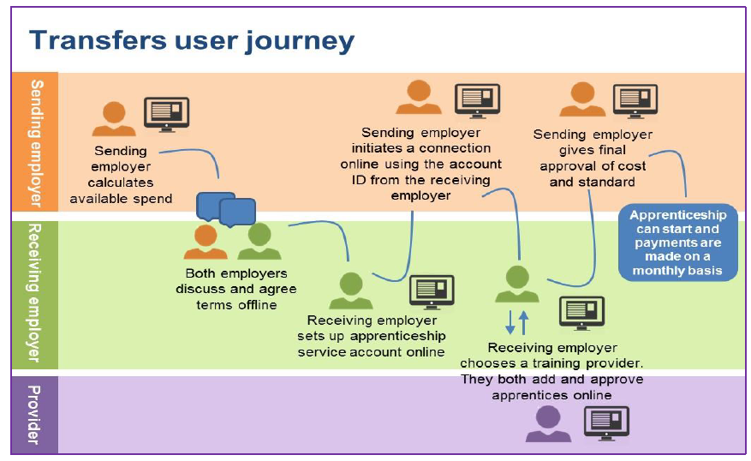

### Stage 1: Digital Apprenticeship Service (DAS) Account Setup

You only need to complete this stage if your organisation does not already have a DAS account set up. If you already have an account, please progress to **Step 2**: **Option 1** or **Option 2** in this guide.

1. **Open the Apprenticeship Service (AS) Account:**

<https://accounts.manage-apprenticeships.service.gov.uk/service/index>

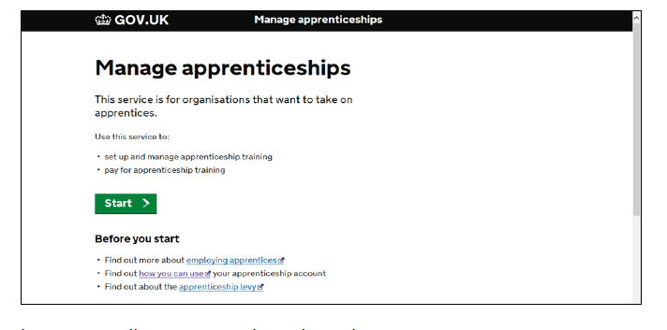

1. **Set up as a user**:

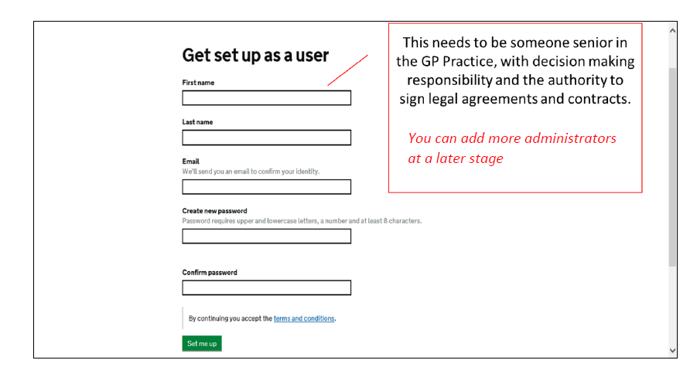

 NB: Please ensure you add more than one user so the practice always has access as without it we cannot progress any transfers and it can take time for the ESFA to respond if you need to try and add someone retrospectively.

The system will then ask for you to complete a security check, which will be emailed to the address that you have supplied**.**

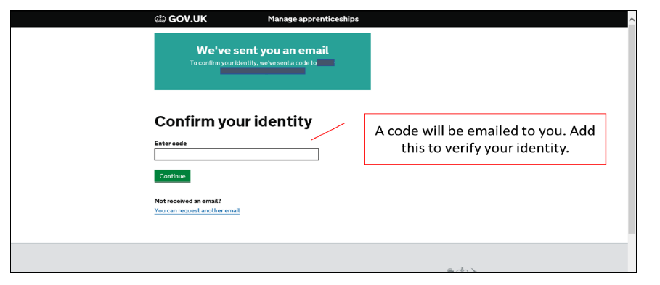

* Retain this information for future reference.
* You are now able to sign-in to the Apprenticeship Service

1. **Signing in to link the account to your organisation:**

• Using the previously set up credentials, sign into your apprenticeship service account.

• It is advisable to save this web page to the favourites within your web browser.

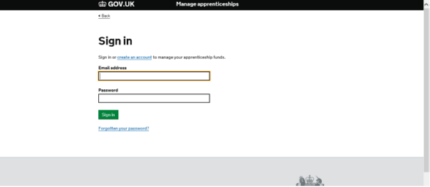

1. **Add your PAYE details:**

You will need your:

* Accounts office reference number
* PAYE scheme reference

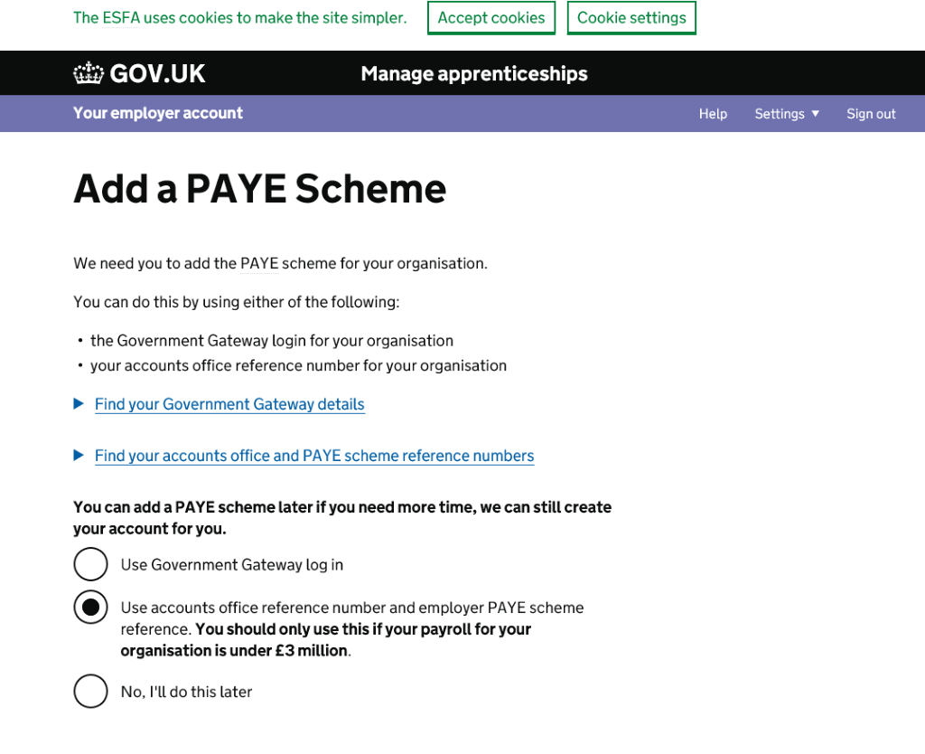

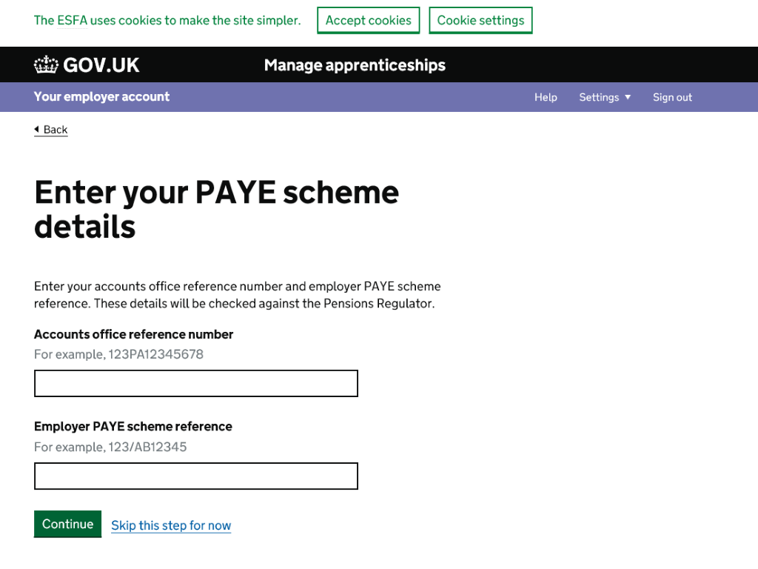

Once you complete the above, your organisation details will appear. You will be required to confirm the organisation details are correct before your DAS account is fully set up.

**Don’t Forget!**

* To read and sign the ESFA Employer Agreement to use your account.
* Set up another user using the ‘Your Team’ tab so someone else in your organisation has access to the account.
* **Send your 6-digit Account ID along with the registered name of your Organisation (as it appears in the DAS account) to the levy team. This can be found at the top left of your home screen within the DAS account and is separate to your agreement ID. We cannot progress a transfer without this.**

### Stage 2: Applying for a Levy Transfer

A Levy Transfer is a funding ‘gift’ for 100% of the cost of the apprenticeship which comes from a large levy paying organisation. They are not guaranteed and so the employer should always ensure they have sufficient funds to pay the 5% co-investment if a 100% transfer is not available

* You will need to complete the NHSE EOI: <https://forms.office.com/e/zcVv9hFgr7>
* We will then contact gifting employers in your area to source a transfer
* **All levy transfers MUST be applied for even if you have existing gifting organisations in your DAS. Please do not add apprentices to existing connections without confirmation as this could lead to them not being approved and you being liable for the apprenticeship funding.**
* **Transfers cannot be applied after the enrolment date so please ensure you apply a minimum of 6 weeks prior to start date.**
* We will notify you once a transfer is confirmed and provide you with the information for next steps including the UKPRN for your training provider

**Next Steps:**

**Accepting a connection request from a levy paying organisation:**

The Team will send your Account ID to the organisation who has agreed to provide you with a levy transfer. The gifting organisation will send you a connection request from their FAS account. When you receive it:

* Log into your DAS account and accept the connection request and then move to **Stage 3: ‘Add your apprentice’**. You will find any connection requests in the ‘Transfers’ section within the ‘Finance’ tab on your Homepage (don’t click on your transfers on front page as takes you to pledging screen to pledge funds).
* Don’t forget to select the correct funding option, ‘fund this Apprentice via a levy transfer’ when the funding options appear.
* You will be given the option to choose from the organisations you have connected with, please make sure you select the correct organisation for this Apprenticeship Levy Transfer
* If this is your first levy transfer or would like support with adding your apprentice please email [england.levytransfer.nw@nhs.net](mailto:england.levytransfer.nw@nhs.net) to request a call with one of the team who will guide you through the process.

### 

### Stage 3: Adding an Apprentice to your Account

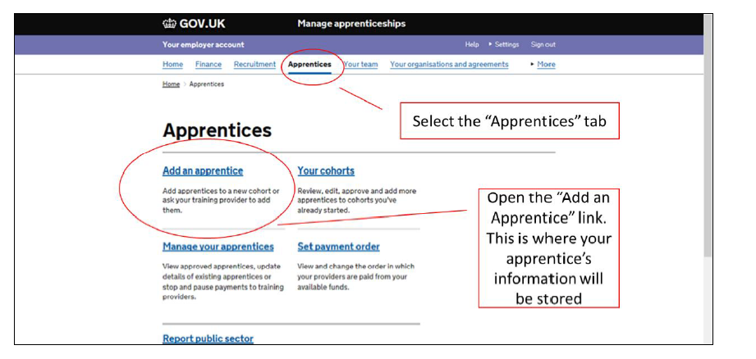

You will need to have some information to hand before you can do this:

* Your Training Provider UKPRN (we usually provide this) but can be found at: <https://www.ukrlp.co.uk/>
* Total cost of the Apprenticeship
* Apprenticeship Standard name for example Nursing Associate (NMC 2018)
* Start and End dates (month) of the Apprenticeship
* Name, Age of apprentice and email address) apprentices 16-21 are now funding fully by Government so will not require a transfer or co-investment

**Do not Forget!**

* **To select the correct funding option, ‘fund this Apprentice via a levy transfer’ when the funding options appear and ensure you are adding against the correct gifting employer. You cannot set up transfers with existing gifting organisatiosn without confirmation that they will support additional apprentices,**

The following screenshots will help guide you through adding your Apprentice to the system:

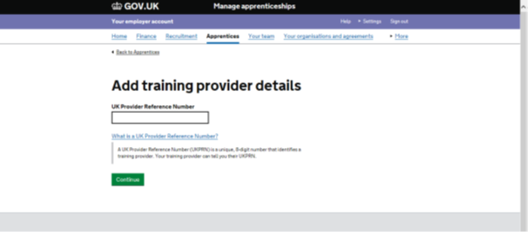

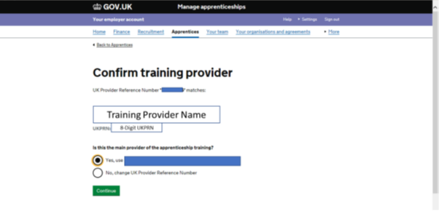

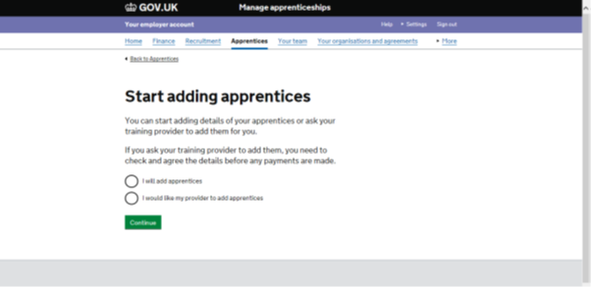

Select option I will add apprentice and use the screen shots below to help you. **We would prefer for you to add the apprentice and send us the cohort reference number than provide permission for the training provider to add them.**

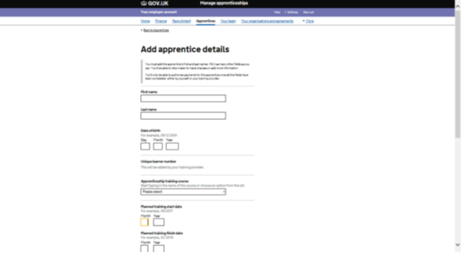

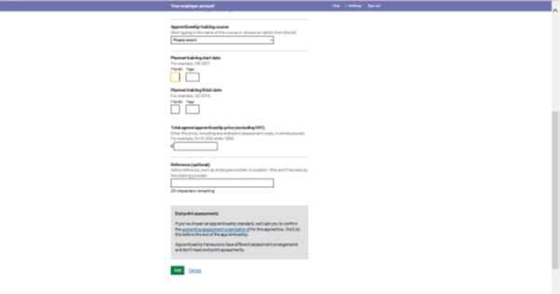

After completing the above, please select the option to save and Submit which will send this Apprenticeship Cohort to the training provider for approval.

**Please remember to:**

* Send you Cohort number to the Apprenticeship Hub. This will be generated once you have added your Apprentice and will appear at the end of the process. Cohort Ref is 6 digits for example:

1. **Final approval:**

The following will need to take place, in the below order, for the transfer to be fully set up:

* Training Provider approval (this may be returned to you if there are any changes which need to be made such as cost or start date you will receive a notification from the training provider)
* Gifting organisation final approval which will trigger the funds being sent to the training provider account. The employer will not see funds within their DAS account from any gifting organisation.

**Please Note:**

If you receive a notification in your DAS account for final approval, please do not accept. Contact the Apprenticeship Hub for further instructions.

1. **Final Account set up – commence training:**

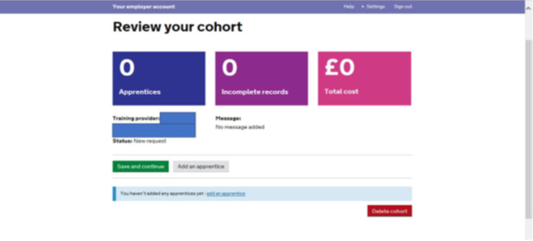

Once all the authorisations and approvals have taken place the Apprentice will be live and active within the system. You can view your apprentice details within the DAS.

If you require any further information, or to speak to us about your Levy Transfer or Co-Investment please email us via:

Email: [england.levytransfer.nw@nhs.net](mailto:england.levytransfer.nw@nhs.net)

ESFA Funding Rules Apprenticeship funding rules - GOV.UK (www.gov.uk)

Health Apprenticeships Standards Online: [Home - HASO (skillsforhealth.org.uk)](https://haso.skillsforhealth.org.uk/)

Support also available from Primary Care Training Hubs below:

