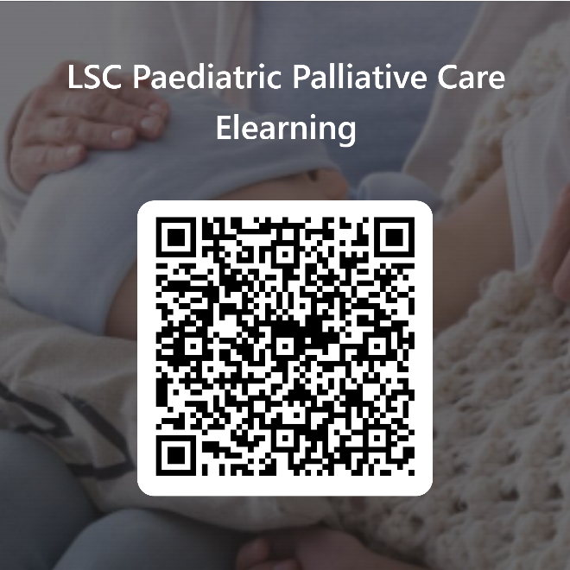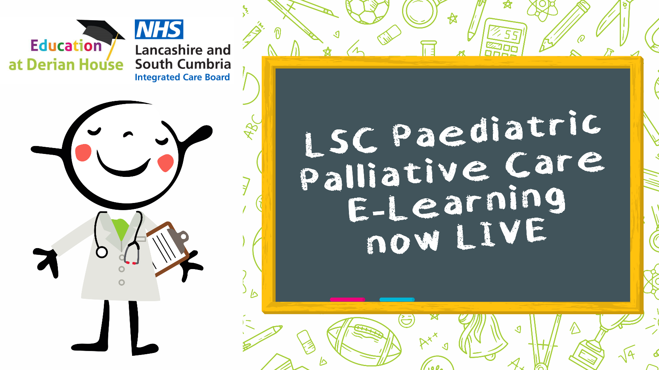

Please use the QR code to register for the Lancashire and South Cumbria & Derian House Paediatric Palliative Care Education Project Elearning modules.

This Elearning library includes;

* Compassionate communication
* When a child is Dying
* Grief and bereavement
* When a child has died
* Symptom management planning
* Advance Care planning

This training is suitable for Health and Social care professionals, volunteers and students who care for babies, children and young people receiving palliative and end of life care in all areas.

Spaces are limited, please use a professional email to sign up to avoid being rejected.