

Community Health and Wellbeing Workers, also referred to as Link Workers or Social Prescribers, are a rapidly expanding workforce, supporting the increasing emphasis across government departments on improving the health of local people and communities by preventing poor health and tackling inequalities.
Training 2000 are delivering this Apprenticeship remotely across England, supporting you with upskilling your existing staff members, developing your workforce whilst aiding retention, as well as helping you to recruit new staff in the most cost-effective way.

Training 2000 would like to invite you to attend one of our information sessions to find out more on our Community Health and Wellbeing Worker Level 3 Apprenticeship and how we can support you.
The information session will include:

- Overview of Training 2000
- Information on how we can help you to recruit Community Health & Wellbeing Workers for free
- How you can upskill your existing workforce or yourself with Training 2000
- The Community Health and Wellbeing Worker Level 3 Apprenticeship content and length
- Course start date
- Information on our flexible, national remote delivery as well as our assessment methods
- Course eligibility criteria
- An overview of how the course is funded
- Progression routes to degree level available via Training 2000 and our parent organisation, the University of Central Lancashire

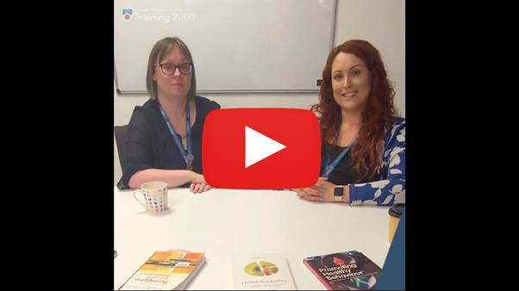
The information sessions will be held via Microsoft Teams at the following dates and times:

To reserve your space please contact our Business Development team with your preferred date on or fill out our online form:

01254 54659 or businessdevelopment@t2000.co.uk

Can’t attend one of the sessions but would like to know more? Please get in touch and one of our team will be happy to help.

Kind regards
Vicky Fort
Lead Account Manager
Business Development

